Securing What Matters: A Practical Framework for Threat and Risk Management in Australia
Australian organisations face evolving risks from cyber threats, insider dangers, and natural disasters. To protect people, information, and reputation, a proactive and strategic security framework is essential.
In a climate of rising uncertainty, where cyber threats, insider risks, and natural disasters converge with public trust and operational resilience, Australian organisations need more than reactive security. They need a strategic framework that protects what matters most: people, information, and reputation.
Threat and risk management have long histories. In Australia, ISO 31000:2018 was adopted to stress senior management involvement and organisational integration. This standard addresses emerging risks like cyber threats and promotes a risk-based approach industry-wide.
This article discusses how Australian organisations can use structured, practical methods for future-oriented threat and risk management.

Why Threat and Risk Management Matters
Threat and risk management transforms uncertainty into actionable insight that protects people, assets, and reputation while enabling data-driven strategic decisions, prioritising resources where they matter most.
This includes striking the right balance between risk reduction and innovation; by embedding risk awareness, rigorously testing response plans, and continually learning from outcomes, organisations build true resilience, earn stakeholder trust through transparent governance and compliance, and empower teams to explore new opportunities with confidence, knowing they have quantified potential downsides and put controls in place.
Whether operating in Australia or elsewhere, the threats we face are real and evolving. From bushfires and floods to data breaches and foreign interference, unmanaged risks can:
- Disrupt critical services
- Erode public trust
- Compromise sensitive information
- Undermine staff safety and wellbeing
Security is not just a compliance checkbox; it is a leadership imperative.

A 9-Step Framework for Protective Security

The below 9-steps are indicative of a generalised protective security framework.
- Identify What to Protect
From personnel and property to data and systems, know critical assets.
- Identify Credible Threats
Use internal reports, external intelligence, and sector-specific insights to map potential disruptions.
- Assess Likelihood
Evaluate how probable each threat is, based on intent, capability, and opportunity.
- Assess Consequence
Use Business Impact Levels to understand the severity of each threat.
- Determine Inherent Risk
Combine likelihood and consequence to rate raw risk before controls are applied.
- Define Acceptable Risk Levels
Align risk appetite with organisational goals, legal obligations, and stakeholder expectations.
- Treat the Risks
Implement controls across governance, personnel, information, and physical security domains.
- Assess Residual Risk
Re-evaluate risks after treatments to ensure they’re within acceptable thresholds.
- Monitor and Evaluate
Regularly review threats, controls, and organisational changes to stay ahead of emerging risks.
The following infographic presents this information in a concise manner.
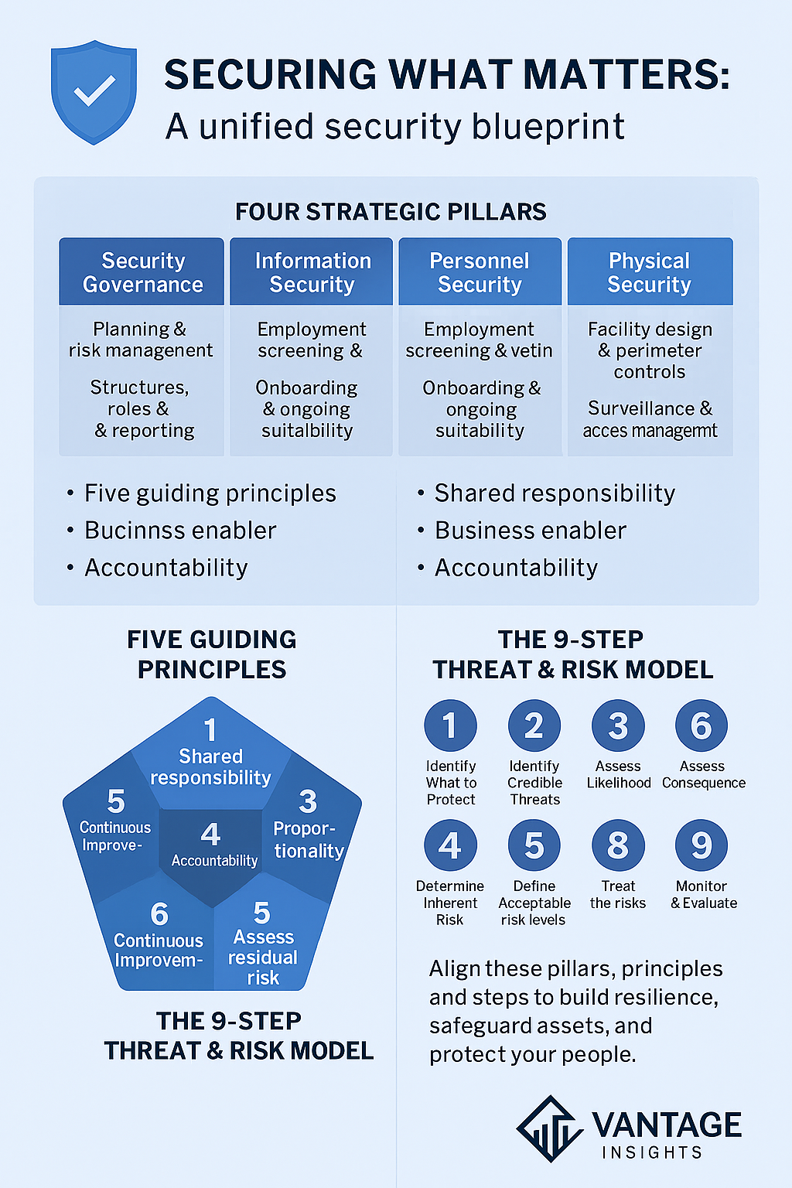
Figure 1- SRM model
Protective security is more than a defensive posture; it is a strategic enabler. For Australian organisations committed to legacy, leadership, and local impact, frameworks like this offer a roadmap to navigate uncertainty with confidence and clarity.

Physical Security Assessment Report: Key Components
A structured template ensures actionable, comprehensive reviews. A Physical Security Assessment Report is essential because it delivers a structured, evidence-based evaluation of your facility’s defences, guiding informed decisions that protect people, assets and operations.
Provides Visibility into Vulnerabilities
- Identifies gaps in fences, access controls, lighting, barriers and surveillance
- Highlights misalignments between design intent and real-world conditions
- Exposes cascading weaknesses where multiple layers may be breached

Informs Prioritization and Resource Allocation
- Ranks risks by likelihood and consequence, so budgets focus on highest-impact fixes
- Guides phased investment plans—urgent hardening measures first, enhancements later
- Prevents ad hoc spending on low-value controls while critical exposures remain

Supports Compliance and Insurance Requirements
- Demonstrates adherence to industry standards, contracts and regulatory frameworks
- Provides documentation needed for audits, tender processes and insurer reviews
- Reduces premium costs by evidencing a mature, risk-based security posture

Drives Executive Buy-In and Funding
- Translates technical findings into business outcomes: downtime avoidance, brand protection, market access
- Supplies quantifiable metrics and real-world examples that resonate with executives
- Integrates seamlessly into an outcomes-driven business case for faster approvals

Enables Continuous Improvement and Monitoring
- Establishes a baseline for future assessments, exercises and control reviews
- Feeds into governance cycles, dashboards and performance metrics
- Triggers updates when environments change, new threats, layout modifications or technology upgrades
Section | Purpose
Executive Summary | Snapshot of major vulnerabilities and priority actions
Scope | Assets, locations, systems, processes under review
Risk Identification | All physical threats (theft, vandalism, access breaches, hazards) and impacts
Risk Assessment & Analysis | Likelihood × Consequence ranking (Low/Medium/High)
Current Security Measures | Existing controls—CCTV, alarms, barriers, access systems, guards
Recommendations | Practical, ordered steps—upgraded cameras, access control, lighting, barriers
Implementation Plan | Timelines, cost estimates, responsibilities
Monitoring & Follow-Up | Review frequency, audit methods, metrics to track control effectiveness

Integrating Frameworks in Practice
9-Step Model Phase | Pillar(s) | Guide | Physical Template Section
Identify What to Protect | Information Security | Part 1 Critical Assets | Scope
Identify Credible Threats | Personnel Security | Part 1 Risk Sources | Risk Identification
Assess Likelihood & Consequence | Governance | Part 2 Analysis | Risk Assessment & Analysis
Treat the Risks | All Four Pillars | Part 3 Treatments | Current Measures & Recommendations
Monitor & evaluate | Continuous Improvement | Part 3 Monitoring | Monitoring & Follow-Up
This cross-mapping ensures:
- Proportionate controls anchored in policy
- Clear accountability and ownership
- A living process that adapts to evolving threats
Partner with independent experts to ensure no gap remains:
- Deep-Dive Assessments
Physical, procedural, and strategic reviews tailor-made for your organisation.
- Customised Recommendations
Practical controls aligned to pillars and best practice, no product sales.
- Implementation Support
Detailed plans with cost-benefit analysis, stakeholder engagement, and timelines.
- Ongoing Monitoring & Audits
Regular reviews, incident debriefs, and dashboard updates to stay ahead of threats.

Strategic Takeaways for Leaders
- Localise the Framework: Adapt model to reflect Australia’s unique threat-scape, think regional protests, climate events, or sector-specific vulnerabilities.
- Embed Ethical Intelligence: Go beyond compliance. Use risk management as a tool for ethical leadership and public trust.
- Empower Executive Oversight: Ensure senior leaders are equipped to make informed, values-driven decisions about risk prioritisation and resource allocation.
- Future-Proof Your Systems: Design treatments that are scalable, flexible, and responsive to evolving threats.

What to Include in Your Physical Security Assessment Report
A comprehensive report template ensures no vulnerability is overlooked. Key components include:
- Executive Summary - A succinct snapshot of major vulnerabilities and priority recommendations—perfect for decision-makers pressed for time.
- Scope of Assessment - Define the perimeter: buildings, entry points, CCTV zones, alarm systems, and operational processes under review.
- Risk Identification - Log every potential threat, unauthorised access, theft, vandalism, environmental hazards, and describe the business impact for each.
- Risk Assessment & Analysis - Rate each risk’s likelihood (low/medium/high) and consequence. These ranking drives prioritisation of treatment efforts.
- Current Security Measures - Document existing controls, surveillance cameras, access protocols, alarm monitoring, perimeter fencing, to highlight strengths and gaps.
- Recommendations for Improvement - Offer clear, actionable steps:
  - Upgrade CCTV coverage or analytics
  - Implement biometric or key-card access
  - Reinforce physical barriers (gates, doors, perimeter fences)
  - Boost lighting and alarm system monitoring
- Implementation Plan - Map out timelines, costs, and responsibilities for each recommendation to guarantee follow-through.
- Monitoring & Follow-Up - Establish regular review cycles and methods for checking the effectiveness of new controls, making security a living, adaptive process
Engaging an independent expert can contribute to comprehensive analysis and introduce an objective perspective that might not be present within the organisation.
- Thorough Risk Assessments - Conduct deep-dive physical and procedural reviews, identifying even hidden vulnerabilities.
- Customised Recommendations - Every business is unique. Tailor solutions, rather than pushing products, to your specific risk profile.
- Ongoing Support - Threat landscape evolves. Provide periodic audits and monitoring to keep defences one step ahead.

Physical Security Assessment Report Template
A structured, comprehensive report ensures no vulnerability is missed:
Section | Purpose
Executive Summary | High-level findings and priority actions
Scope | Assets and processes assessed (buildings, access control, CCTV, alarms, etc.)
Risk Identification | Catalogue threats (theft, vandalism, natural hazards) and their business impacts
Risk Assessment & Analysis | Rate likelihood and consequence (Low/Medium/High) to prioritise treatments
Current Security Measures | Document existing cameras, perimeter controls, access protocols, and guards
Recommendations | Practical, ordered steps (e.g., barrier upgrades, lighting, biometric access)
Implementation Plan | Timelines, cost estimates, responsible teams
Monitoring & Follow-Up | Review cycles, audit methods, and metrics to track effectiveness
Effective security is not a checkbox; it is a strategic enabler. By blending a proven 9-step threat management model with a rigorous physical security assessment framework, Australian organisations can build resilience, earn community trust, and safeguard their legacy.

Integrating Protective Security Frameworks with Threat & Physical Security Assessments
Aligning these frameworks creates a unified security roadmap:
9-Step Model Phase | Pillar | Physical Assessment Template Section
Step 1 “Identify What to Protect” | Information Security | Scope of Assessment
Step 2 “Identify Threats” | Personnel Security | Risk Identification
Step 3–5 “Assess Risk” | Security Governance | Risk Assessment & Analysis
Step 7 “Treat the Risks” | All Four Pillars | Current Measures & Recommendations
Step 8–9 “Review & Monitor” | Continuous Improvement | Monitoring & Follow-Up
By cross-referencing the pillars, principles, and report sections, you ensure:
- Controls are proportionate and owned at the right level
- Security remains a live, evolving discipline
- Strategic documents underpin every step
Partnering with independent experts closes gaps you might miss:
- Deep-dive physical and procedural reviews
- Tailored, practical recommendations aligned to pillars
- Ongoing support with periodic audits and real-time monitoring

Four Strategic Pillars

Protective security frameworks consist of four strategic pillars.
- Security Governance
- Information Security
- Personnel Security
- Physical Security

Security Governance (Governance Security – GOVSEC)
This pillar sets the strategic foundation, ensuring security aligns with organisational goals and is managed consistently.
- Establishes policies, standards and procedures that define how security is delivered and governed.
- Clarifies roles, responsibilities and accountability across leadership, risk owners and operational teams.
- Integrates security into corporate governance, reporting and audit cycles.
- Drives continuous improvement through performance metrics, reviews and executive oversight.

Information Security (INFOSEC)
Focused on safeguarding data and systems, this pillar ensures that information remains confidential, intact and available.
- Implements classification schemes to label data by sensitivity and business criticality.
- Enforces access controls, encryption and secure configurations for networks, applications and devices.
- Monitors and detects anomalies through logging, security analytics and incident response processes.
- Supports business enablement by balancing usability with risk reduction, enabling safe information sharing and collaboration.

Personnel Security (PERSEC)
People are both the first line of defence and a potential source of risk; this pillar manages that dynamic.
- Conducts vetting and background checks to confirm trustworthiness and suitability for roles with security implications.
- Defines clearances, separation of duties and rotation policies to limit insider threats.
- Delivers ongoing security training, awareness campaigns and behavioural monitoring.
- Maintains processes for incident reporting, disciplinary measures and exit procedures to protect assets throughout an individual’s lifecycle.

Physical Security (PHYSEC)
This pillar prevents, detects and responds to threats against tangible assets, infrastructure and people.
- Designs layered controls, perimeter fencing, barriers, locks and secure zones, to deter and delay intruders.
- Deploys surveillance (CCTV), intrusion detection systems and access control technologies at critical points.
- Positions guards, patrols and reception screening to provide dynamic oversight and rapid response.
- Plans for resilience with emergency power, environmental controls and maintenance to keep facilities operational under stress.

Governance Security - Controls (GOVSEC)
- GOVSEC 1 – Security Planning & Risk Management
Chief Executive or delegate approval of a security plan.
- GOVSEC 2 – Management Structures & Responsibilities
Appointed Chief Security Officer and Chief Information Officer.
- GOVSEC 3 – Training & Awareness
Mandatory security awareness for all staff and contractors.
- GOVSEC 4 – Accountability & Risk Management
Chief Executive reports on PSF approach to Minister/Government/Board/Committee.
- GOVSEC 5 – Testing Security Plans
Revise plans when risks or operational environments change.
- GOVSEC 6 – Security Incident Reporting
Procedures for identifying, reporting, investigating, and correcting incidents.
- GOVSEC 7 – Compliance & Attestation
Annual attestation of protective security adequacy.
- GOVSEC 8 – Contractor Obligations
Ensure third-party compliance with PSF requirements.

Physical Security Controls (PHYSEC)
- PHYSEC 1 – Risk-based policies, procedures, and measures for safe facilities
- PHYSEC 2 – Embed security early in planning, design, and modification of sites
- PHYSEC 3 – Safeguard ICT assets from physical tampering or damage

Personnel Security Controls (PERSEC)
- Identity Verification & Screening for access to resources
- Additional Vetting for higher-risk roles
- Onboarding Guidance on protective security obligations
- Ongoing Suitability Reviews for employees in sensitive roles
- Secure Separation processes at termination

Information Security Control (INFOSEC)
- INFOSEC 1 – Compliance with relevant Information Standard

Guiding Principles
- Shared Responsibility – Every employee fosters a positive security culture
- Business Enabler – Proportionate security supports service delivery and community trust
- Proportionality – Controls match assessed risks and organisational appetite
- Accountability – Chief Executive and delegates own security outcomes
- Continuous Improvement – Evolve controls through learnings and emerging threat
By uniting a Protective Security Framework, a 9-step risk model, and a rigorous physical assessment template, you transform security from a compliance checkbox into a strategic enabler. Embrace shared responsibility, proportionality, accountability, and continuous improvement to build resilience, bolster community trust, and safeguard your legacy.
In today’s complex environment, security can no longer live in silos or be treated as a checkbox exercise. By uniting four strategic pillars, Governance, Information, Personnel and Physical Security, with a structured 9-step risk model, a practical assessment template, and outcomes-driven business case techniques, you create a resilient, agile posture that aligns directly to business goals.
- This blueprint transforms security from a cost centre into a strategic enabler. It empowers you to:
- Translate technical findings into board-level outcomes, downtime prevention, market access, brand protection Prioritise investments by likelihood and consequence, not by impulse or budget cycle
- Embed controls across infrastructure, technology, people and procedures in a living, adaptive overlay
- Secure executive buy-in by speaking the language of growth, efficiency and risk reduction
A blueprint is only as powerful as its execution. The next step is dependent upon the will of an organisations leadership to accept and to implement.
- Map controls and treatment plans to the risk appetite defined by leadership.
- Schedule first (or next) physical security assessment and benchmark against these pillars.
- Develop a concise executive summary, focus on three high-impact recommendations tied to ROI.
- Launch operational readiness exercises to validate your integrated overlay in action.
Security is not a one-off project, it is an ongoing journey of monitoring, learning, and continuous improvement. Embrace this unified approach now, and organisations not only withstand the threats of tomorrow but also seize the opportunities they present.

